DIVERTOR UPPER PART

**Extro Single Lever Divertor Trim (2-Function)**

**Product Description:**

The Extro Single Lever Divertor Trim is a sleek, wall-mounted external control plate designed to pair with a concealed diverter body. It facilitates seamless switching between two water outlets such as a showerhead and hand shower, all while blending modern aesthetics and functional elegance.

**Key Features (Single-line format)**

✅ Sleek round chrome plate with minimalist lever design  
✅ Dual outlet operation for shower/tub or shower/hand shower  
✅ Smooth lever control with integrated hot/cold indicator  
✅ Premium-grade brass with durable chrome finish  
✅ Compatible with standard 2-function diverter bodies

**Product Specifications**

**Brand:** Extro  
**Model:** Single Lever Divertor Trim (2-Function)  
**Material:** Brass + Stainless Steel plate  
**Finish:** Chrome Plated  
**Mounting Type:** Wall-mounted (external trim)  
**Operation:** Single Lever  
**Inlet Support:** Designed to fit 2-way concealed diverter body  
**Indicators:** Hot (Red) & Cold (Blue) markers  
**Compatible Use:** Bathroom shower/tub systems  
**Warranty:** 5 Years (may vary by supplier)

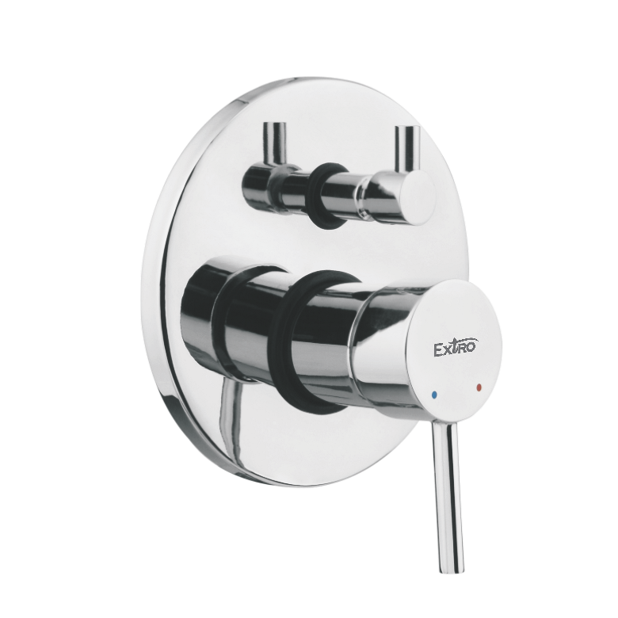

**Extro Single Lever Divertor Trim with Paddle Handle (2-Function)**

**Product Description:**

The Extro Single Lever Divertor Trim with Paddle Handle is a contemporary wall-mounted control unit that allows smooth switching between two water outlets. Designed with a broader ergonomic handle, this trim enhances grip and operation while maintaining modern bathroom aesthetics.

**Key Features (Single-line format)**

✅ Paddle-style lever for enhanced grip and user comfort  
✅ Dual outlet operation for versatile water flow control  
✅ Mirror-polished chrome finish for lasting shine  
✅ Clear hot/cold indicators for temperature safety  
✅ Compatible with standard 2-way concealed divertor bodies

**Product Specifications**

**Brand:** Extro  
**Model:** Paddle Handle Divertor Trim (2-Function)  
**Material:** Brass body with stainless steel plate  
**Finish:** Chrome Plated  
**Mounting Type:** Wall-mounted (external trim)  
**Handle Type:** Flat paddle lever  
**Functionality:** Controls two water outlets  
**Indicators:** Red (Hot) and Blue (Cold) temperature marks  
**Application:** Shower/Tub/Hand Shower System  
**Warranty:** 5 Years (subject to manufacturer policy)

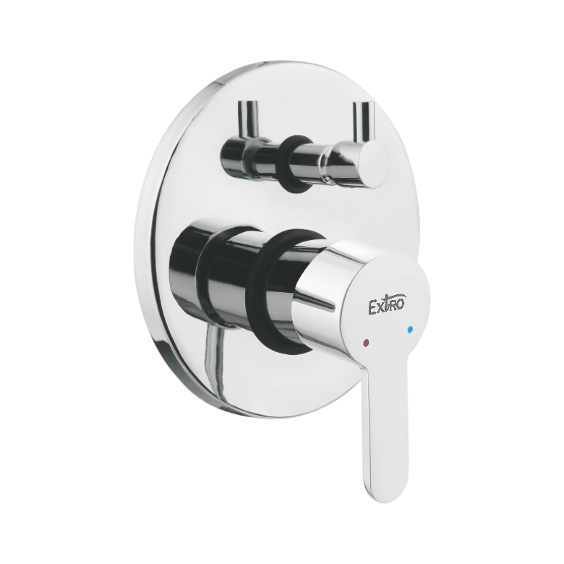

**Extro Single Lever Divertor Trim with Square Paddle Handle (2-Function)**

**Product Description:**

The Extro Square Paddle Handle Divertor Trim is a modern and stylish wall-mounted control unit that effortlessly blends aesthetics with utility. Designed with a square contour and a smooth lever operation, it enables convenient switching between two water outlets in bathroom shower systems.

**Key Features (Single-line format)**

✅ Sleek square paddle handle for a bold, modern look  
✅ Chrome-plated finish resists corrosion and tarnish  
✅ Smooth lever movement ensures effortless operation  
✅ Dual outlet control compatible with 2-way systems  
✅ Hot and cold color indicators for added safety

**Product Specifications**

**Brand:** Extro  
**Model:** Square Paddle Handle Divertor Trim (2-Way)  
**Material:** Brass trim with stainless steel faceplate  
**Finish:** High-gloss Chrome Plated  
**Handle Type:** Wide square paddle lever  
**Mounting:** Wall-mounted (trim kit)  
**Functionality:** Controls two water outlets  
**Indicators:** Red (Hot) and Blue (Cold)  
**Compatibility:** Fits standard 35mm 2-way concealed bodies  
**Application:** Shower or Bath Mixer Systems  
**Warranty:** 5 Years (subject to terms and conditions)

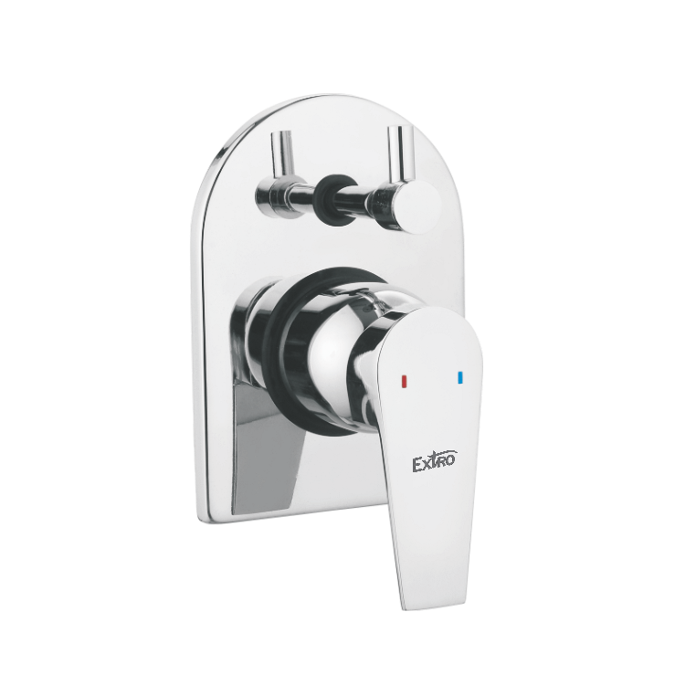

**Extro Single Lever Divertor Trim with Loop Handle (2-Function)**

**Product Description:**

The Extro Loop Handle Divertor Trim offers a unique blend of ergonomic design and modern appeal. Featuring a distinctive open-loop lever, this wall-mounted trim is ideal for effortlessly managing two water outlets in your bathroom setup.

**Key Features (Single-line format)**

✅ Unique loop handle design for easy grip and operation  
✅ Elegant chrome finish enhances durability and aesthetics  
✅ Smooth and reliable lever control for two-way flow  
✅ Clearly marked hot and cold directions for user safety  
✅ Compatible with standard 35mm 2-way concealed valves

**Product Specifications**

**Brand:** Extro  
**Model:** Loop Handle Divertor Trim (2-Way)  
**Material:** Solid brass construction with stainless steel plate  
**Finish:** High-quality chrome plating  
**Handle Type:** Ergonomic open-loop lever  
**Mounting:** Wall-mounted (front trim assembly)  
**Functionality:** Controls 2 water outlets (shower/bath etc.)  
**Compatibility:** Fits with 35mm 2-way concealed diverter body  
**Indicators:** Hot (red) and Cold (blue) direction cues  
**Application:** Bathroom mixer systems  
**Warranty:** 5 Years (T&C apply)

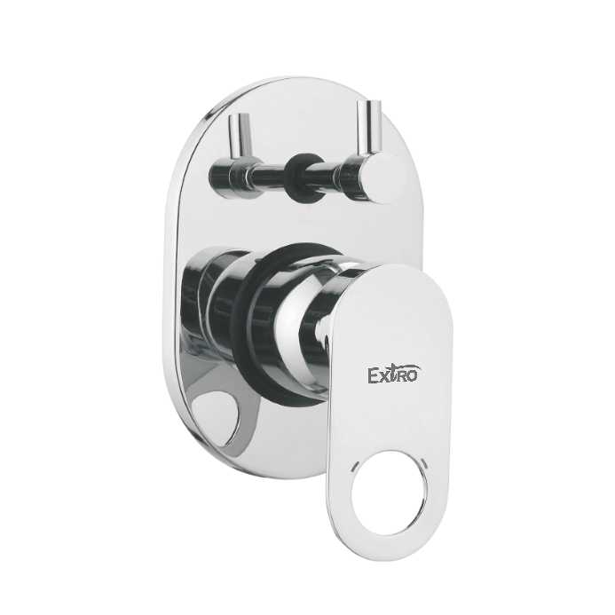

**Extro Single Lever Divertor Trim with Capsule Handle (2-Function)**

**Product Description:**

The Extro Capsule Handle Divertor Trim offers a sleek, minimalist design paired with ergonomic functionality. Its capsule-shaped lever ensures smooth operation and a sophisticated look for modern bathroom interiors.

**Key Features (in single line)**

✅ Stylish capsule handle design with modern aesthetics  
✅ Smooth operation with hot & cold directional indicators  
✅ Premium chrome finish for long-lasting durability  
✅ Supports dual outlet flow control for showers or bath fittings  
✅ Easy wall-mount installation with concealed body compatibility

**Product Specifications**

**Brand:** Extro  
**Model:** Capsule Handle Divertor Trim (2-Way)  
**Material:** Brass body with stainless steel faceplate  
**Finish:** Mirror-like chrome plating  
**Handle Type:** Soft-edge capsule lever  
**Mounting:** Wall-mounted (front trim kit only)  
**Functionality:** Controls two water outlets (e.g., overhead & hand shower)  
**Indicators:** Red and Blue hot/cold markers  
**Valve Compatibility:** Fits with 35mm 2-way concealed diverter cartridge  
**Application:** Bathroom faucet/divertor control  
**Warranty:** 5 Years (as per manufacturer policy)

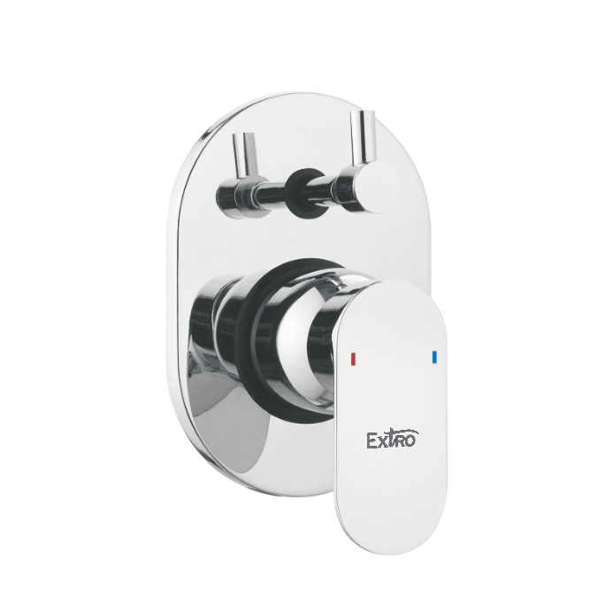

**Extro Single Lever Divertor Trim with Edge Handle (2-Function)**

**Product Description:**

The Extro Edge Handle Divertor Trim is crafted for contemporary bathrooms, offering a bold rectangular handle and plate for precise water flow control. Its sharp geometric design adds a touch of elegance and modernity to your bath space.

**Key Features (in single line)**

✅ Rectangular edge handle design with premium chrome finish  
✅ Dual outlet functionality for versatile shower control  
✅ Smooth operation with integrated hot/cold indicators  
✅ Corrosion-resistant brass construction ensures longevity  
✅ Quick and easy installation with concealed compatibility

**Product Specifications**

**Brand:** Extro  
**Model:** Edge Handle Divertor Trim (2-Way)  
**Material:** Brass body with stainless steel faceplate  
**Finish:** High-gloss chrome plating  
**Handle Type:** Flat rectangular lever  
**Mounting:** Wall-mounted (front trim kit only)  
**Functionality:** Controls two outlets (e.g., overhead & spout/shower)  
**Indicators:** Red (hot) and Blue (cold) markings  
**Valve Compatibility:** Fits 35mm 2-way concealed cartridge system  
**Application:** Bathroom diverter control panel  
**Warranty:** 5 Years (manufacturer standard)

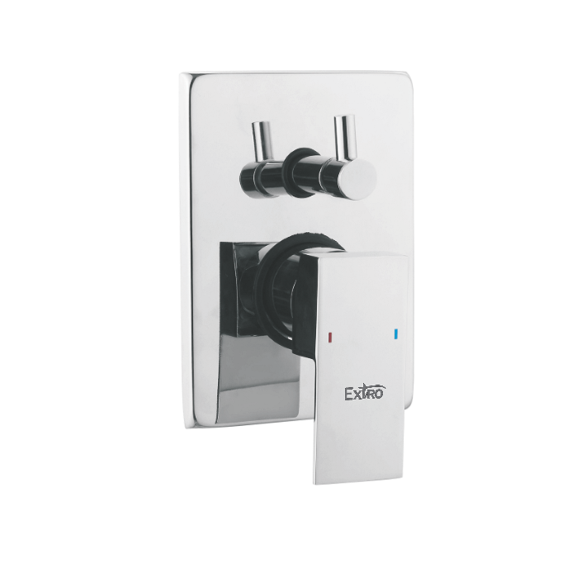

**Left to Right**

**🔹 1. Extro Single Lever Divertor Trim – Round Handle (2-Way)**

**Product Description:**

A sleek and practical diverter trim with a minimalist round lever, designed for seamless hot and cold water control with modern aesthetics.

**Key Features:**

* Sleek round lever for effortless control
* Dual-function diverter for versatile use
* Rust-proof chrome finish for long-term shine
* Smooth operation with ceramic cartridge
* Ideal for concealed wall-mount systems

**Specifications:**

* **Material:** Brass body
* **Finish:** Chrome plated
* **Plate Shape:** Circular
* **Control:** 2-way diverter
* **Hot/Cold Indicators:** Yes
* **Installation:** Wall-mounted trim kit

**2. Extro Single Lever Divertor Trim – Flat Oval Handle (2-Way)**

**Product Description:**

A modern diverter trim with an elegant soft oval lever, offering comfort grip and smooth flow regulation for your bathroom setup.

**Key Features:**

* Ergonomic oval handle with color markers
* Sturdy brass body ensures durability
* Clean oval faceplate matches any decor
* Easy grip and control for hot/cold mixing
* Compatible with 35mm ceramic cartridge

**Specifications:**

* **Material:** Brass with chrome finish
* **Plate Shape:** Oval
* **Handle Design:** Slim flat oval
* **Control Function:** 2 outlets
* **Color Indicators:** Red & Blue
* **Mounting Type:** Concealed wall

**🔹 3. Extro Single Lever Divertor Trim – Designer Loop Handle (2-Way)**

**Product Description:**

A unique designer trim featuring a loop-style handle for stylish bathrooms with enhanced grip and aesthetic flair.

**Key Features:**

* Loop-style handle with smooth edges
* Durable construction with high-gloss finish
* Dual water outlet control functionality
* Stylish addition to modern interiors
* Compatible with standard diverter body

**Specifications:**

* **Material:** Brass
* **Finish:** Mirror chrome plating
* **Handle Type:** Loop cutout
* **Control Function:** 2-way diverter
* **Plate Design:** Designer oval plate
* **Installation:** For concealed systems

